**NITTE MEENAKSHI INSTITUTE OF TECHNOLOGY**

(AN AUTONOMOUS INSTITUTION, AFFILIATED TO VISVESVARAYA TECHNOLOGICAL UNIVERSITY, BELGAUM, APPROVED BY AICTE & GOVT.OF KARNATAKA



**PHOENIX MUSIC PLAYER**

*Submitted in partial fulfilment of the requirement for the Android development Lab LA component in VI semester*

*Bachelor of Engineering*

*in*

*Computer Science and Engineering*

*Submitted by:*

|  |  |
| --- | --- |
| MOHAMED RAYAN KHAZI | 1NT18CS098 |
| SAKSHI THAKUR | 1NT18CS141 |
| SHROOTHI SINGH | 1NT18CS156 |

Under the Guidance of

SUPRIYA C

Dept. of CS&E, NMIT



Department of Computer Science and Engineering

2020-21

**NITTE MEENAKSHI INSTITUTE OF TECHNOLOGY**

(AN AUTONOMOUS INSTITUTION, AFFILIATED TO VISVESVARAYA TECHNOLOGICAL UNIVERSITY, BELGAUM

, APPROVED BY AICTE & GOVT.OF KARNATAKA)

Department of Computer Science and Engineering

**(Accredited by NBA Tier-1)**



**CERTIFICATE**

This is to certify that the report on **MUSIC PLAYER** is an authentic work carried out by **MOHAMED RAYAN KHAZI (1NT18CS098), SAKSHI THAKUR (1NT18CS141)** and **SHROOTHI SINGH (1NT18CS156)** bonafide students of **Nitte Meenakshi Institute of Technology**, Bangalore in the partial fulfilment for the Course “ANDROID APP DEVELOPMENT LA Component” in VI Sem of the degree of ***Bachelor of Engineering*** in COMPUTER SCIENCE AND ENGINEERING of Visvesvaraya Technological University, Belagavi during the academic year ***2020-21.*** It is certified that all corrections and suggestions indicated during the internal assessment has been incorporated in the report.

|  |  |  |
| --- | --- | --- |
| **Internal Guide** |  | **Signature of the HOD** |
|  |  |  |
| SUPRIYA C  Dept. CSE,  NMIT Bangalore |  | Dr.Thippeswamy M. N.  Professor, Head, Dept. CSE, NMIT Bangalore |

**ACKNOWLEDGEMENT**

The satisfaction and euphoria that accompany the successful completion of any task would be incomplete without the mention of the people who made it possible, whose constant guidance and encouragement crowned our effort with success. I express my sincere gratitude to our Principal **Dr. H. C. Nagaraj**, Nitte Meenakshi Institute of Technology for providing facilities.

We wish to thank our HoD**, Dr. Thippeswamy M.N.** for the excellent environment created to further educational growth in our college. We also thank him for the invaluable guidance provided which has helped in the creation of a better project.

I hereby like to thank our ***SUPRIYA C*** , Department of Computer Science & Engineering on **her** periodic inspection, time to time evaluation of the project and help to bring the project to the present form.

We take this opportunity to thank our Departmental Project coordinators. We also thank all our friends, teaching and non-teaching staff at NMIT, Bangalore, for all the direct and indirect help provided in the completion of the project.

|  |  |
| --- | --- |
| **NAME** | **USN** |
| MOHAMED RAYAN KHAZI | 1NT18CS098 |
| SAKSHI THAKUR | 1NT18CS141 |
| SHROOTHI SINGH | 1NT18CS156 |

**DECLARATION**

We the undersigned solemnly declare that the report of the project work entitled “**PHOENIX MUSIC PLAYER**” is based on our own work carried out during the course of our study under the supervision of Supriya C.

We assert that the statements made and conclusions drawn are an outcome of the project work. We further declare that to the best of our knowledge and belief that the project report does not contain any part of any work which has been submitted for the award of any other degree/diploma/certificate in this University or any other University.

|  |  |
| --- | --- |
| **NAME** | **USN** |
| MOHAMED RAYAN KHAZI | 1NT18CS098 |
| SAKSHI THAKUR | 1NT18CS141 |
| SHROOTHI SINGH | 1NT18CS156 |

**ABSTRACT**

Music is one of the best ways to relieve pressure in stressful modern society life. The purpose of this project is to develop a player which can play the mainstream file format. In order to solve the problem of complex functions of mobile phone music player on the current market, a new music player of simple, convenient, less required memory as well as user-friendly is developed. Based on the Android technology, using the Java language and Android Studio programming tools lead to design and coding of music player. The new design mainly realizes six core functions including main play interface, playlists, menus, play settings, favourites and song search. This player has merits of high performance, simple operation, and run independently on the Android mobile devices. At the same time, the player can also browse and access songs in mobile phones.

**CONTENTS**

1. INTRODUCTION
2. OBJECTIVES
3. BUILD DEVELOPMENT ENVIRONMENT
4. SYSTEM REQUIREMENTS SPECIFICTION
5. DESIGN
6. MODULES AND STRUCTURES
7. CONCLUSIONS
8. REFERENCES
9. **INTRODUCTION**

Android is open source code mobile phone operating system that comes out by Google in November 2007. Its appearance has broken the traditional closed mobile phone operating system. Anyone can modify the mobile phone operating system as well as function according to personal preference, which is also the most attractive merit of Android. Music player in this article is application software based on Google Android.

Android’s application on mobile terminals also completely broke the traditional understanding of the mobile terminals. And appreciate music is one of the best ways to relieve pressure in stressful modern society life. Therefore, many kinds of mobile phone players are also developed. However, a lot of players devote to fancy appearance and function, while caused resources wasting to the user's mobile phone, such as large required memory and CPU, which brings a lot of inconvenience as multiple programs running at the same time. For the most ordinary users, many functions are useless.

The purpose of this article is to develop a player which can play the mainstream music file format. To browse and query the storage space as well as operation of adding, deleting, and playing can be realized. Meanwhile, this software can play, pause and select songs with latest Btn and next Btn according to users’ requirement as well as set up songs’ order and etc,.

Music player based on Android application is popular in the market at the present. The completing development of Android operating system gives developers a nice platform, which can learn the popular computer technology combining with learned knowledge, and master the latest knowledge, enrich oneself, and enjoy entertainment.

Music player in this project is application software based on Google Android. Music is one of the best ways to relieve pressure in stressful modern society life. The purpose of this project is to develop a player which can play the mainstream file format. To browse and query the storage space as well as operation of playing can be realised. Meanwhile, this software can play, pause and select songs with latest button and next button according to sets requirement as well as set up songs.

1. **OBJECTIVES**

Music player in this project is application software based on Google Android. Music is one of the best ways to relieve pressure in stressful modern society life. The purpose of this project is to develop a player which can play the mainstream file format. To browse and query the storage space as well as operation of playing can be realized. Meanwhile, this software can play, pause and select songs with latest button and next button according to sets requirement as well as set up songs.

The objective of this thesis is to propose development of android that:

**1. Make it with a simple feature and run smoothly**

By using this mp3 music player will make users fell comfortable and relaxed because it will pay more attention to the features commonly used by users, excluding some rarely used features that occupy a large of system processors, making the music player lightweight, simple, but also has powerful basic features.

**2. Support gesture control**

The MP3 music player will add features triggered by gestures to make it easier for users to use as well as less dependent on touch buttons. For example, a user can skip next or previous pages by simply swiping left and right on the anywhere of the screen in the playing interface.

**3. Support quick search**

The lack of a search bar in the music list is unacceptable. Therefore, the mp3 music player will use the search bar as well as fast scroll using alphabets on the right side of the screen, allowing users to quickly filter through hundreds of songs to find the ones users want to play.

**4. Support favouriting**

Bookmarking or marking our favourite songs within the playlist we are listening to, not only helps it easy to find them, but also helps to remember our favourite genres or likes and dislikes in songs.

1. **BUILD DEVELOPMENT ENVIRONMENT**

The application of android need to run based on Android environment.

The following is the configuration requirement and installation steps of Android development environment:

The required software of the developing environment

* Operation system: Windows 10,Linux
* Software Android SDK(Software Development Kit)、ADT(Android Development Tool)
* JDK：Java Runtime Environment virtual machine、Java Development Kit(JDK)

Installation steps of the developing environment

1. Install the Java virtual machine JDK version - 7
2. Install the Android SDK: first download the Android SDK
3. Download address: http://developer-android-com/sdk/index-html
4. Input SDK tools path in the SDK location: D: \ android \ software \ android SDK– Windows and click OK.
5. The Android environment is set up successfully.
6. **SYSTEM REQUIREMENTS SPECIFICATION**

**Functional Requirements**

•  Android operating system on the Smartphone.

•  The target device should be sound enabled

•  The android version should not be less than 2.3.5

**Software Requirement**

1. Android Studio

2. Java SE 8

**Hardware Requirements to Run the APP**

**1. Laptop**

- Processor: Intel(R) Core(TM) i7-4500U CPU @ 1.80GHz 2.40 GHz

- RAM: 4.00 GB

- Hard Disk storage: 500 GB Hard Disk

- Operating System: Windows 10 Professional Edition

**2. Smartphone device**

- Processor make: Qualcomm Snapdragon 652 (MSM8976)

- RAM: 4.0 GB

- Phone Storage: 64 GB

- Operating System: Android version 5.1.1 (Lollipop)

**3. OTHER REQUIREMENTS**

Maintain ability: The design will be updated based on any changes, which are done during coding stage to maintain proper trace ability.

Availability: Available for minimum API level 22 (Android Lollipop 5.1)

1. **DESIGN**

The App Starting module of the player in the project is introduced, as well as the Android engineering program structure, etc.

Any App starting needs AndroidManifest. XML file to start. And any new project content will automatically generate an AndroidManifest. XML file. Configuration files are the core of the whole program, which contains the Android SDK version, and the default Activity in program running. The systems will automatically looking for a logo in AndroidManifest to react the corresponding operation when any component of the program triggers events.

To define the system, the first thing is launching the Activity: Android Activity. There are properties such as action and category in < intent - filter >. Most of these are the default values of the system. Setting the action and category realize the switch between different Activities. When any components of the program is about to use, declaration must be in the Android Manifest. Xml files.

To be clear that authorities must be illustrated as the statement of provider. Each component has a lot of attributes; the program will define different attributes according to different needs.

The basic structure content of Android project includes: the SRC (source code), gen (constant that Android system automatically generates), res (resource file), and the layout of file and pictures in the main storage program interface.

**Part of the function design:**

The main play interface design.

Convenience and practicality should be fully considered in the design of the main interface. Every Android interface is a visual interface, which has its unique layout configuration files. We can configure various layout and resources files according to the requirements, such as images, text and color reference, which can form different visual interface and glaring effect.

**Interface design of adding songs.**

There are no corresponding songs for the first time login entering the program; users need to add songs to play. Therefore, you need to enter the adding songs’ interface. The empty playlist needs to add songs which can choose from the SD card to add.

Function design of play and Next/Move Previous music

i. When need to use the player to play appropriate music, click the play button to realize the function.

ii. When need to use the player to switch to the previous song, click on “Move Previous music” button to realize the function.

iii. When need to use the player to play the next song, click on “the next music” button to realize the function.

**USER MODULES**

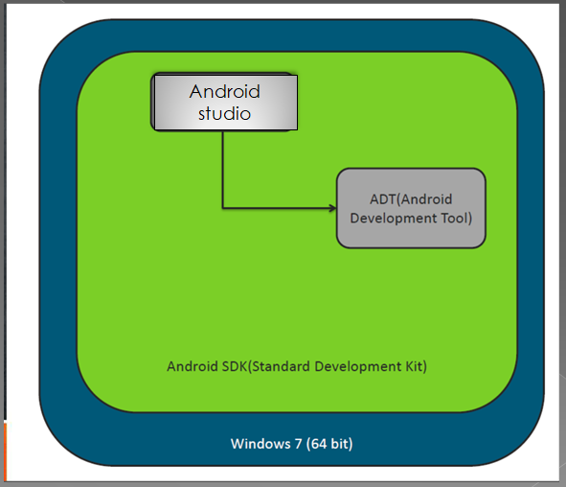

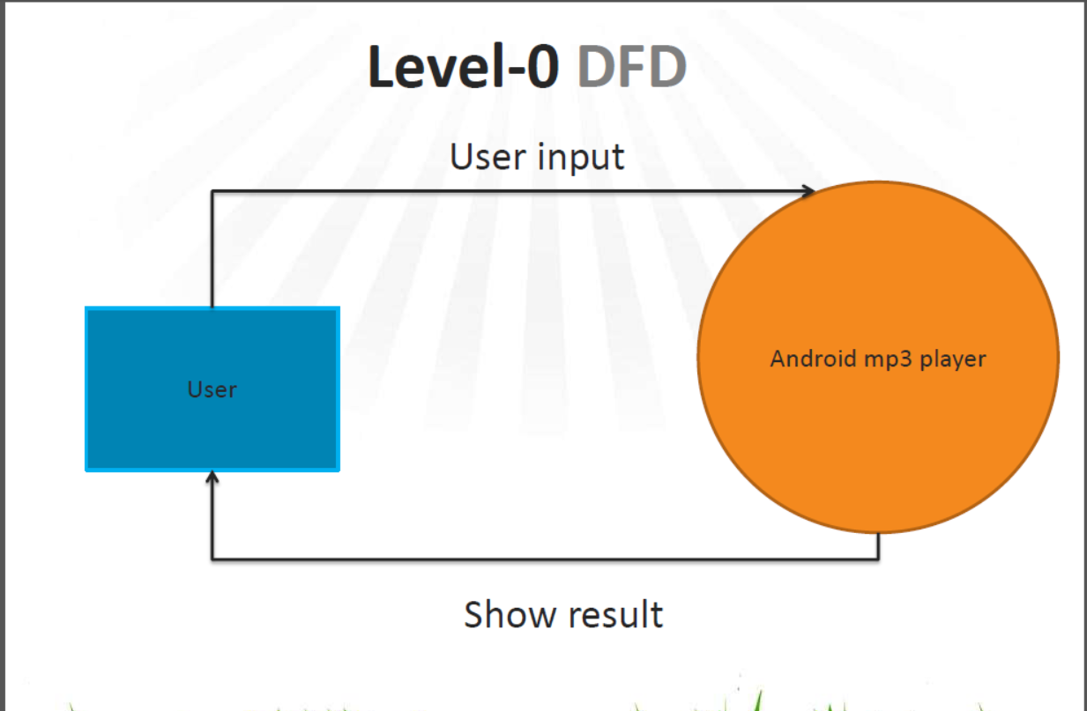

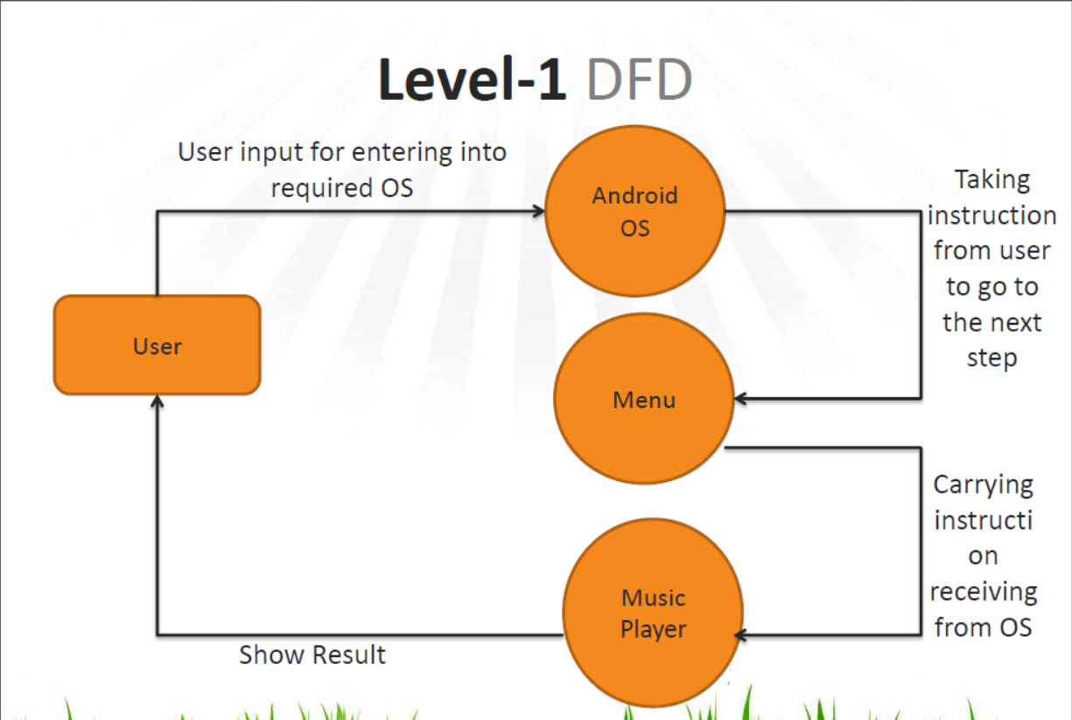

**FLOWCHART**

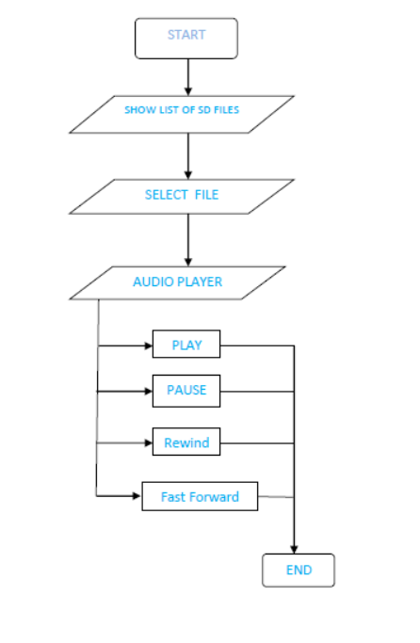

Favourite

**SCREENSHOTS**

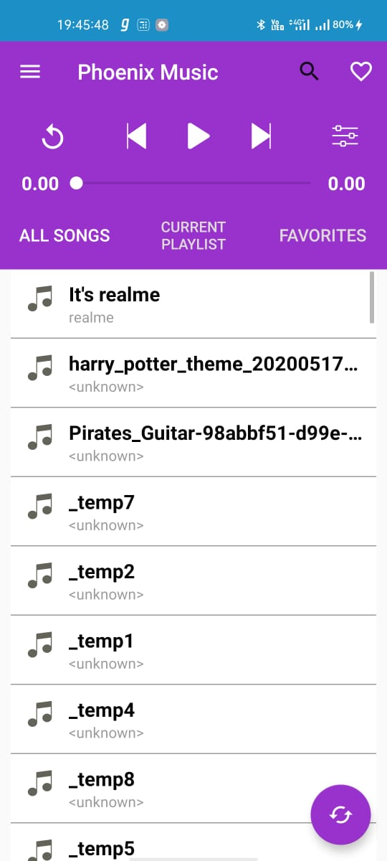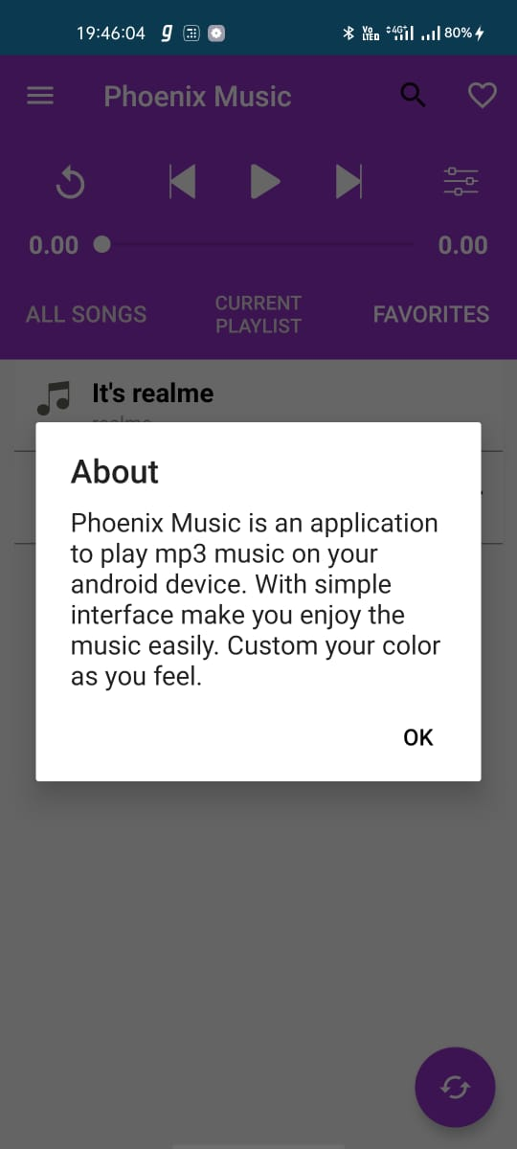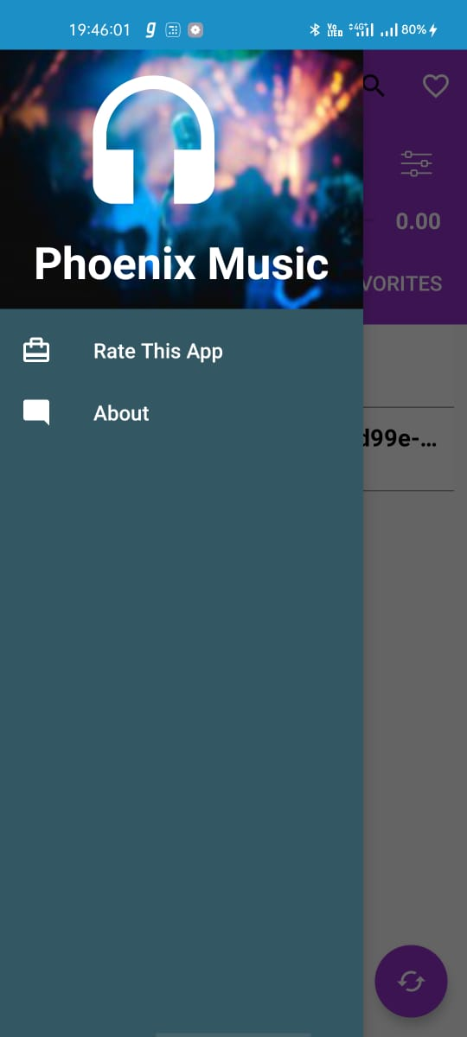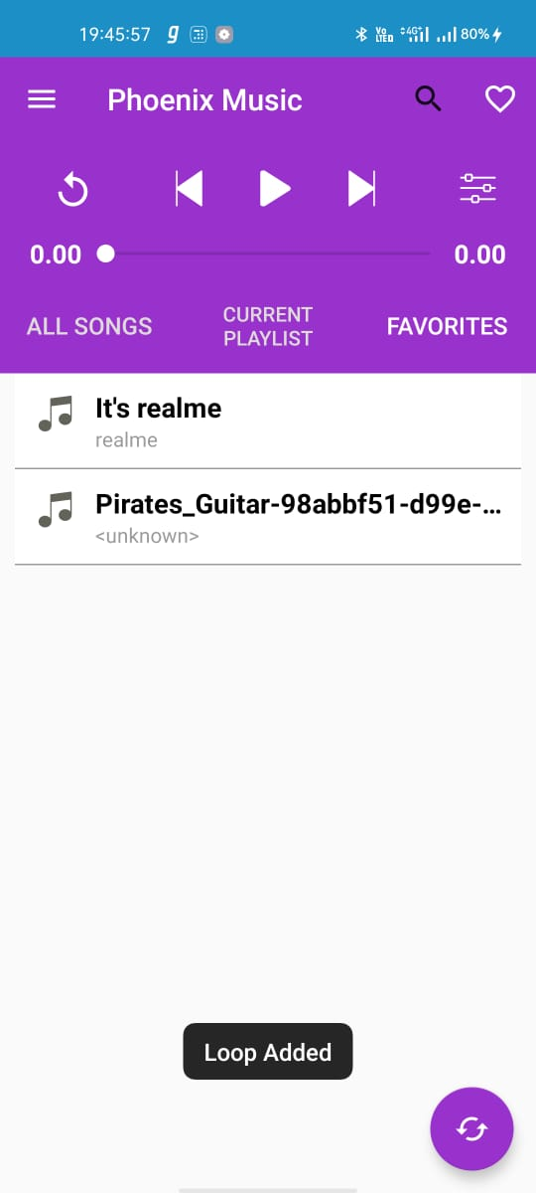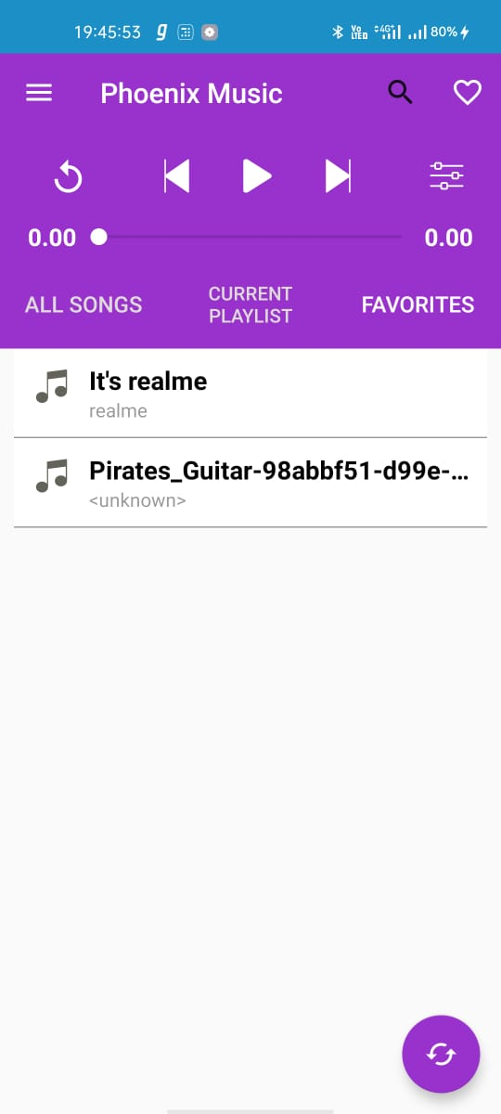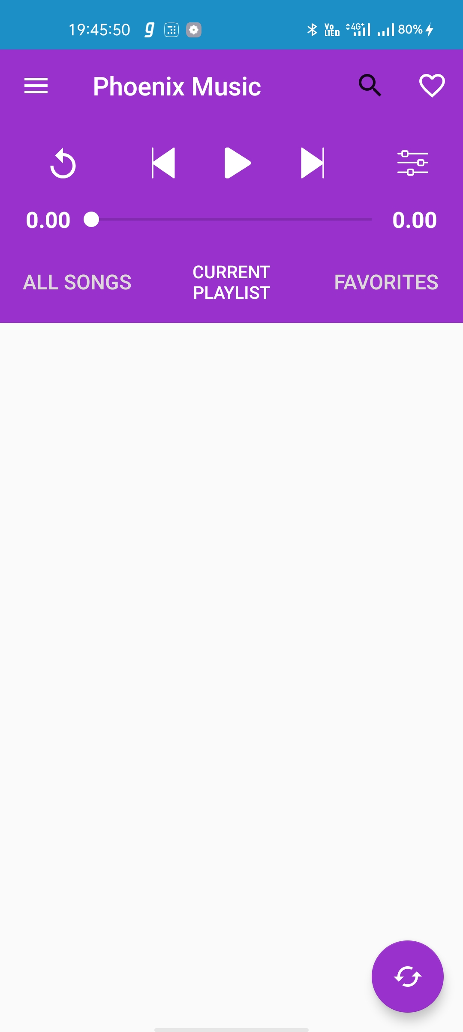

1. **MODULES AND STRUCTURE**

This system adopts the **modularized program design**.

• System function is divided into modules:

1. UI function module design of mobile terminal:

• The index screen

• Play screen

• Music adding page

• File management page

2. Backstage function module design of mobile terminal:

• The specific function

• Music file data storage

**Playlist design**:

• The List View shows song’s name in every row.

• We expand the adapter through algorithm, in which a picture and a song’s name can be shown in the first line.

**The design and realization of play menus**:

• Includes six functions- play, content, add, delete, delete all & setting

**Data storage**: Android provides the following ways for data storage:

• Preference (configuration)

• File (documents)

• SQLite data

1. **CONCLUSION**

Through the development of music player on Android platform, we get a clear understanding of overall process of the system. The core part of the music player is mainly composed of main interface, file browsing and song listing, Grasping the development of the music player has had the preliminary scale small features.

Music player system realized the basic function of player: play, pause, rewind and favourite a, volume adjustment is performed through the Android System Itself, play mode, song search, seekbar, This development implicated the popular mobile terminal development technology. This is the combination management of Java language in the open source mobile platform based on Linux system configuration file. The system realized the music player programming.

This design of music player based on Android system requires elaborate design of the music player framework, by adopting ANDROID STUDIO 3.1.2 + Java language as technical support of this system, with the Android plug-in tools, and combination of Latest Android SDK version lead to the comprehensive and smoothly design and development of the mobile terminal.

1. **REFERENCES**
2. <http://eprints.utar.edu.my/3793/1/16ACB05288_FYP.pdf>
3. <http://www.ir.juit.ac.in:8080/jspui/bitstream/123456789/16834/1/121318.pdf>
4. <http://amarandroid.blogspot.com/2013/04/hexadecimal-color-codes-list-using-in.html>
5. <http://developer.android.com/index.html>
6. <http://www.androiddevelopers.in/>
7. <http://www.androidpolice.com/>
8. <http://android.wordpress.org/>
9. <https://code.google.com/p/connectbot/>
10. <http://www.google.co.in/mobile/android/>
11. <http://www.lynda.com/> (Android development video tutorial).